Shaping Volcanoes
Aim: To find out if the composition of volcanoes affects the angle of repose.
Hypothesis: _____________________________________________________________________________
Variables:
Independent _____________________________
Dependent _____________________________
Controlled _______________________________________________________
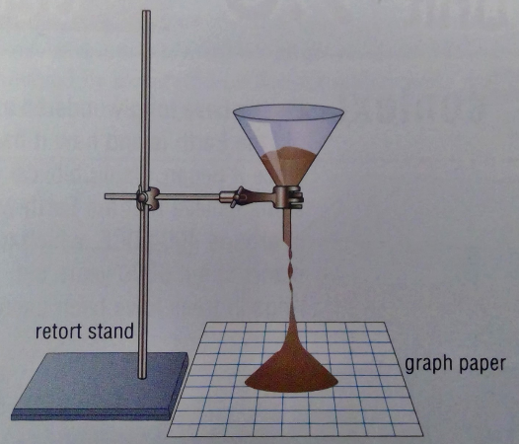
Materials:

- Funnel
- Retort stand
- Boss head and clamp
- Graph paper
- Ruler
- Sand
- Flour
- Iron filings
- Protractor
- Calculator

Figure 1
Method:
- Set up the funnel and retort stand as shown in diagram 1 above.
- Place your finger over the bottom end of the funnel and fill it with sand.
- Remove your finger and let the sand run out.
- Measure the height of the sand mound created on the graph paper.
- Use the graph paper to estimate the diameter of its base.
- Calculate its radius.
- Construct a scale diagram of the side-view (cross-section) of the mound.
- Use a protractor to measure the angle that the sand makes with the horizontal (the angle of repose).
- Put the angle on your diagram (see figure 2 below).
- Repeat steps 2-9 for the other samples of flour and iron filings.

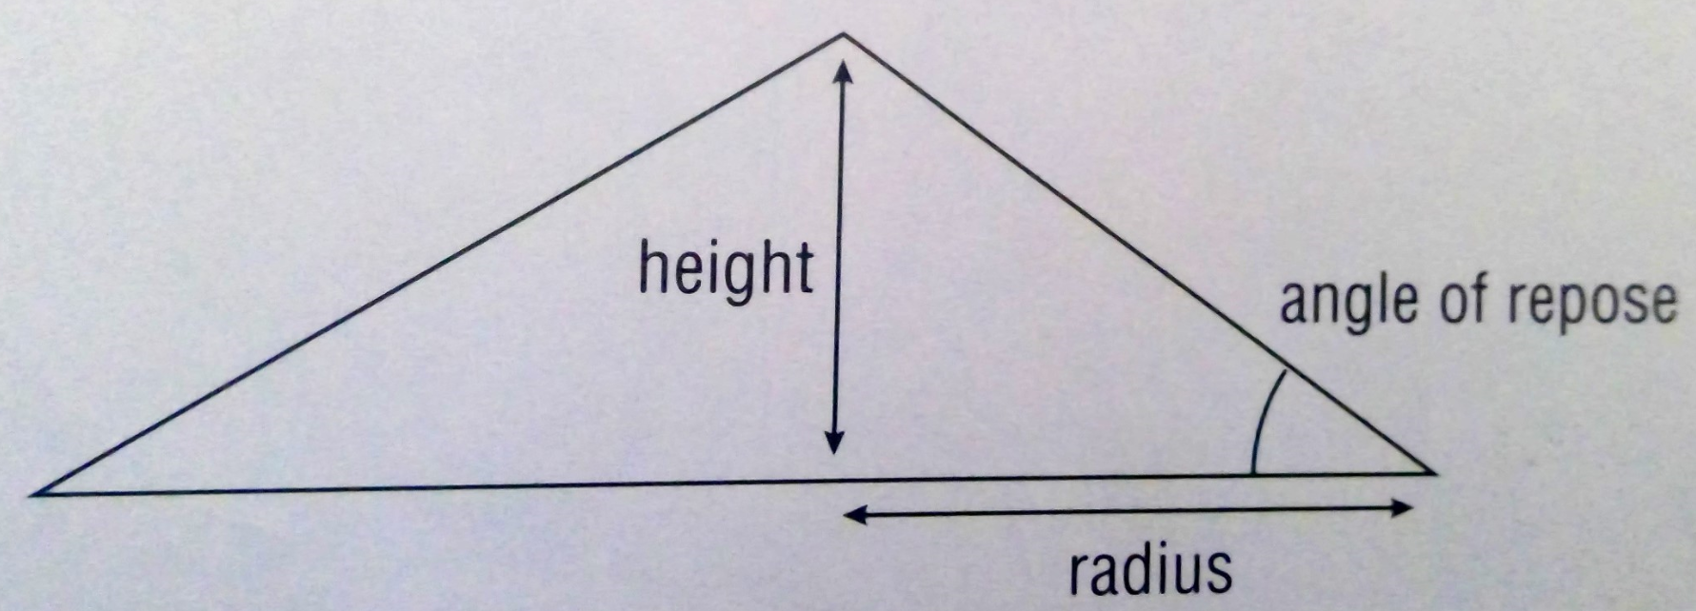
Figure 2

Results:
Material | Height (cm) | Diameter (cm) | Radius (cm) | Circumference (cm) | Angle of Repose (°) | Diagram
Sand
Flour
Iron Filings

- Arrange the materials in order from smallest to largest angle of repose. ______________________________________________________________________________________________________________________________________________________

- Assess why the angles might differ between the materials. _________________________________________________________________________________________________________________________________________________________________________________________________________________________________

- Suggest whether bigger volcanoes have different angles to smaller volcanoes of the same material. _________________________________________________________________________________________________________________________________________________________________________________________________________________________________

Discussion:
- Do the results of this experiment support the hypothesis? Use the data obtained to support your answer. ____________________________________________________________________________________________________________________________________________________________________________________________________________________________________________________________________________________________________________

- How does this experiment simulate the formation of volcanoes? _________________________________________________________________________________________________________________________________________________________________________________________________________________________________
___________________________________________________________________________

Conclusion:
Does the composition of volcanoes affect their angle of repose? ______________________________________________________________________________________________________________________________________________________

Evaluation:
- Suggest one error that may have occurred during this experiment. ______________________________________________________________________________________________________________________________________________________

- Did this error affect the accuracy of your results? ______________________________________________________________________________________________________________________________________________________

- How could this error be avoided, to increase the reliability of the experiment? ______________________________________________________________________________________________________________________________________________________

